MCA Application for President-Elect
Office for President-Elect will be held in 2024.
Will serve as President-Elect in 2025 and President in 2026
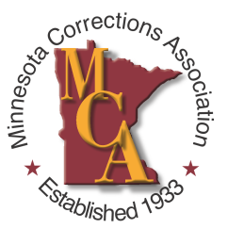
Please e-mail a photo and this bio sheet by July 30th
Name:
E-mail Address: Phone Number:
Agency you currently work for/retired from:
BIO (175 words or less)
Work Experience:
Education:
Professional Association Activities:
Question for the Candidate
What can you tell the MCA membership about your interest in running for this position on the MCA Board of Directors?

What makes you the best candidate for this MCA Board position?

What are the most pressing issues facing corrections today and what should be MCA’s role regarding these issues?

